PRACTICAL-6

Performs finite-state analysis on a sentence to check its validity

Finite-State Automaton (FSA)

An FSA is a mathematical model that recognizes whether a sequence of words/symbols follows certain grammar rules.

It consists of states, transitions, and accepting states.

In your second code:

States represent progress in parsing a sentence (e.g., start → determiner → adjective → noun → verb).

Transitions occur based on the category of the word (DET, ADJ, NOUN, VERB).

If the sentence ends in the accepting state (S4), it is valid; otherwise, it is rejected.

Example: "The big red cat jumped" → follows grammar path DET → ADJ → NOUN → VERB → valid.

CODE:-
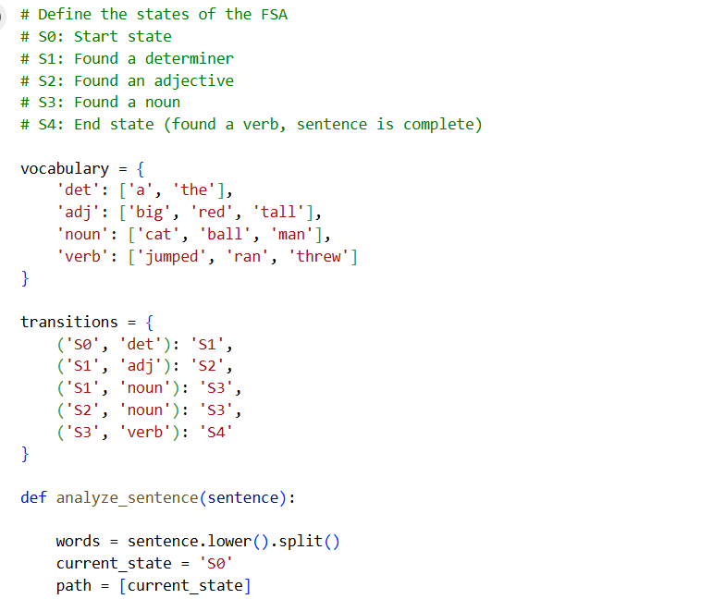

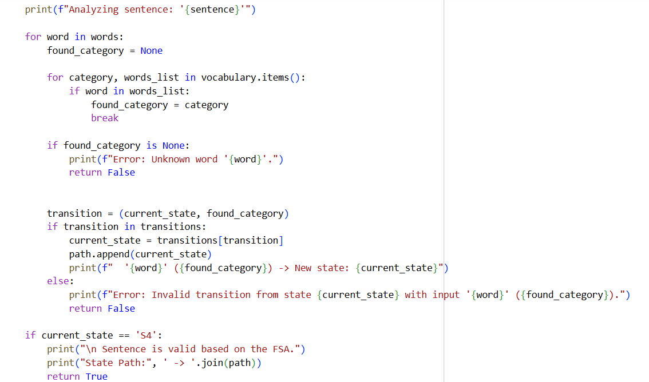
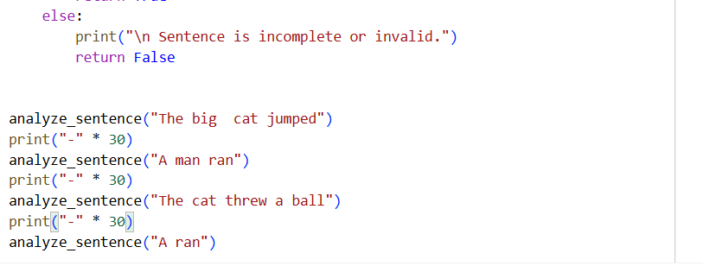

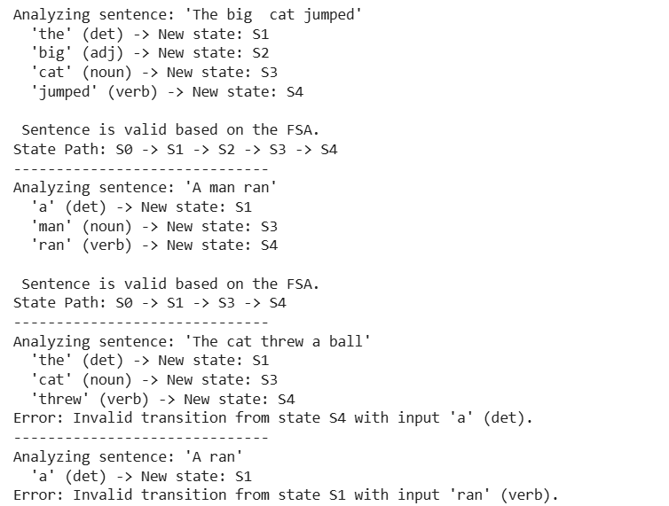
Output:

Finite-State Transducer (FST):

An FST extends the FSA: instead of just checking if input is valid, it also produces an output tape (a transformed version of the input).

Used widely in lexical analysis, morphology, and NLP (e.g., converting surface words to lemmas + grammatical tags).

In the first code I gave you:

Input = "The quick brown fox runs"

Output (lexical tape) = the+DET quick+ADJ brown+ADJ fox+N+SG run+V+3SG

The FST both accepts the input and transduces it into structured information.

Example: "dogs" → dog+N+PL

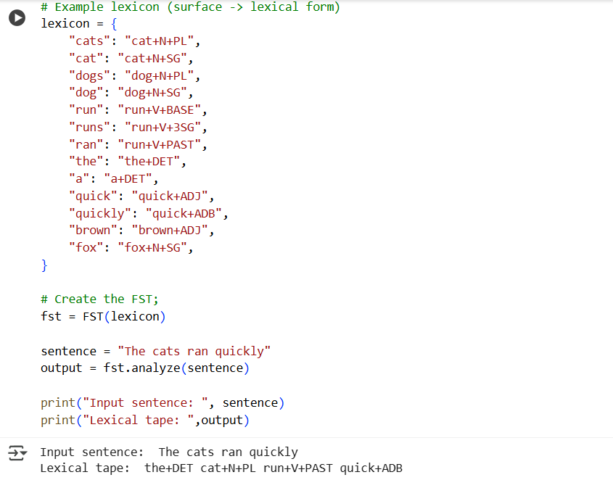
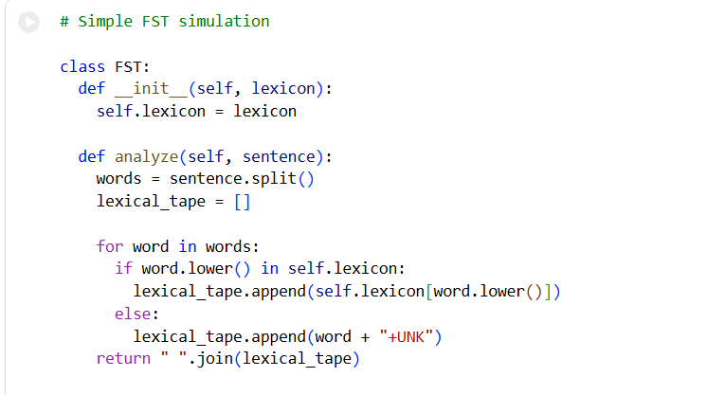
CODE:-

